**B.N.M. Institute of Technology**

**An Autonomous Institution under VTU**

**Approved by AICTE, Accredited as Grade A Institution by NAAC till 31.12.2026.**

**All Eligible UG branches – CSE, ECE, EEE, ISE & Mech. Engg. Accredited by NBA till 30.06.2025**

**Post box no. 7087, 27th cross, 12th Main, Banashankari 2nd Stage, Bengaluru- 560070, INDIA**

**Ph: 91-80- 26711780/81/82   Email:**[**principal@bnmit.in**](mailto:principal@bnmit.in)**,** [**www.bnmit.org**](http://www.bnmit.org)



**OBJECT ORIENTED PROGRAMMING USING JAVA- 22CSE136**

**(Project Based Learning Course)**

**PROJECT REPORT**

**ON**

# **“STOCK MANAGEMENT SYSTEM”**

**by**

**CHINMAYI N** **1BG22CS037**

**DEEPIKA DEVIDAS KANTRIKAR** **1BG22CS039**

**HASINI D 1BG22CS058**

Under the guidance of

Dr. Raghavendra C K

Associate Professor

Dept. of CSE

BNMIT



**B.N.M. Institute of Technology**

**An Autonomous Institution under VTU**

**Approved by AICTE, Accredited as Grade A Institution by NAAC till 31.12.2026.**

**All Eligible UG branches – CSE, ECE, EEE, ISE & Mech. Engg. Accredited by NBA till 30.06.2025**

**Post box no. 7087, 27th cross, 12th Main, Banashankari 2nd Stage, Bengaluru- 560070, INDIA**

**Ph: 91-80- 26711780/81/82   Email:**[**principal@bnmit.in**](mailto:principal@bnmit.in)**,** [**www.bnmit.org**](http://www.bnmit.org)

**Department of Electrical and Electronics Engineering**



**CERTIFICATE**

Certified that the Project entitled **“STOCK MANAGEMENT SYSTEM”** carried out by **CHINMAYI N (1BG22CS037),** and **DEEPIKA DEVIDAS KANTRIKAR (1BG22CS039), HASINI D (1BG22CS058),** bona fide students of **III semester,** during the year **2022-2023,** for the fulfillment of the academic requirements for the Project Based Learning Course **Object oriented programming using java (22CSE136).**

The Project report has been approved as it satisfies the academic requirements in respect to the course.

|  |  |
| --- | --- |
| **Dr. Chayadevi M L** | **Dr. Raghavendra C K** |
| Professor and Head | Associate Professor |
| Dept. of CSE | Dept. of CSE |
| BNMIT, Bangalore | BNMIT, Bangalore |

**External Examination:**

|  |  |  |
| --- | --- | --- |
| **Sl. No.** | **Name of the Examiners** | **Signature and date** |
| 1 |  |  |

**Abstract**

This abstract explores the mission and objectives of stock management software, with a focus on enhancing inventory control processes and operational efficiency for businesses, especially within the ecommerce domain. Stock management systems play a crucial role in tracking, managing, and optimizing inventory levels to prevent overstocking or under stocking of items.

The primary goal of stock management software is to maintain an optimal stock level while ensuring efficiency in financial and material availability. Through automation of inventory tracking, product information management, and reorder point generation, these systems empower businesses to make informed decisions and mitigate risks of product obsolescence and spoilage.

**Acknowledgment**

We would like to place on record our sincere thanks and gratitude to the concerned people, whose suggestions and words of encouragement has been valuable.

We express our heartfelt gratitude to **BNM Institute of Technology**, for giving us the opportunity to pursue Degree of **Computer Science And Engineering,**  and helping us to shape our career. We take this opportunity to thank **Prof. T. J. Rama Murthy**, Director, **Dr. S.Y. Kulkarni,** Additional Director**, Prof. Eishwar N Maanay,** Deanand **Dr. Krishnamurthy G.N.,** Principal for their support and encouragement to pursue this project. We would like to thank **Dr. R.V. Parimala,** Professor and Head, Dept. of Electrical and Electronics Engineering,for her support and encouragement.

We would like to thank our Guide **Dr. Raghavendra C K,** Associate Professor**,** Dept. of Electrical and Electronics Engineering**,** who has been the source of inspiration throughout our project work and has provided us with useful information at every stage of our project.

Finally, we are thankful to all the teaching and non-teaching staff of Department of Electrical and Electronics Engineering for their help in the successful completion of our project. Last but not the least we would like to extend our sincere gratitude to our parents and all our friends who were a constant source of inspiration.

**CHINMAYI N**

**DEEPIKA DEVIDAS KANTRIKAR**

**HASINI D**

**Table of Contents**

Abstract……………………………………………………………………...i

Acknowledgement.…………………………………………………………ii

List of Figures…………………………………………................................ iv

Chapter 1- Introduction……………………………………….………….…1

Chapter 2-Literature Survey………………………………….………….….7

Chapter 3-Methodology…………………... ……………………………….10

Chapter 4- Hardware and Software requirement………………………...…14

Chapter 5- Results and Discussion …….……………………………….….21

Chapter 6- Conclusion and Future Scope………………….…………….….26

References

Appendix

**List of Figures**

|  |  |  |
| --- | --- | --- |
| **Figure No.** | **Description** | **Page No** |
| 1.1 | Smart Greenhouse System Prototype | 3 |
| 3.1 | Block Diagram of proposed Greenhouse System | 11 |
| 3.2 | Flowchart of proposed Greenhouse System | 11 |
| 4.1 | ESP32 | 14 |
| 4.2 | DHT11 Sensor | 14 |
| 4.3 | Soil Moisture Sensor | 15 |
| 4.4 | LDR sensor | 15 |
| 4.5 | Fan | 16 |
| 4.6 | Motor Pump | 16 |
| 4.7 | LED | 17 |
| 4.8 | LCD | 17 |
| 4.9 | Relay Module | 18 |
| 4.10 | Jumper Wires | 18 |
| 4.11 | Battery | 19 |
| 4.12 | Arduino IDE logo | 19 |
| 4.13 | Blynk App Logo | 20 |
| 5.1 | Arduino IDE Console Log showing sensor values | 21 |
| 5.2 | Blynk Application showing sensor values | 21 |
| 5.3 | LCD showing sensor values | 22 |
| 5.4 | Fan Turning On | 22 |
| 5.5 | Pump Turning Off | 22 |
| 5.6 | Led Turning Off | 22 |
| 5.7 | Blynk Readings with colors for illustration | 23 |
| 5.8 | Smart Greenhouse System Frontal view | 24 |
| 5.9 | Smart Greenhouse System Side View | 24 |

**CHAPTER-I**

**INTRODUCTION**

* 1. **Introduction**

As India is a developing economy, make in India is such a step taken to develop Indian industrial sector by replacing man power with automated machines in all sectors but in fact most of the people in India depend on agriculture. The Agriculture is the backbone of India's economic activity. More than 55% of India's population relies on agriculture and it contributes about 15% to the overall GDP. Due to in adequate rain and less profitable crops many of them were not able to use automated machines. They were depending on many traditional ways of cultivating. In recent days many research institutions founded green houses for growing crops in controlled climatic conditions which will yield more produce with fewer inputs such as water, manures, etc. Now days due to more imports the domestic industry has ruptured a lot and many duplicate seeds which reduced yield and harmed many people. Many institutions formed as NGO’s to develop these modern methods for farming. Green houses are deployed in India at high attitude places where temperature varies from minus degrees to forty degrees where living organism’s survival is difficult. Green Houses are controlled rooms where physical inspection of plants is done with timely controlling of temperatures, limiting to the quantity of pesticides and fertilizers required for cultivating with proper observation and testing’s. This entire process is completed with proper coordination of men and machines. For example: Henry Ford is the first person who introduces first assembly line with the combination of automatic and manual workers. A person can do many errors but a computer cannot. In the same way greenhouses automation will reduce human errors which incur in traditional way of cultivating. Controls were setup in order to interact with the environment when required. As discussed earlier India is a developing economy and having less money can’t afford such huge investment. Hereby, a Greenhouse monitoring and automation is a big step which is taken to make it not much expensive in large scale production.

As the world is trending into new technology and implementing. It is a necessary goal to trend up with agriculture also; IOT plays a very important role in smart agriculture. In IOT - based smart greenhouse farming, a system is built for monitoring the crop field with the help of sensors (light, humidity, temperature, soil moisture, etc.) and automating the irrigation system. The farmers can monitor the field conditions from anywhere. IOT - based smart greenhouse farming is highly efficiently when compared with the conventional approach. Greenhouse farming is a methodology that helps in enhancing the yield of vegetables, fruits, crops etc. Greenhouses control the environment parameters through manual intervention or a proportional control mechanism. As manual intervention results in production loss, energy loss, and labour cost, these methods are less effective. A smart greenhouse can be designed with the help of IOT, this design intelligently monitors as well as controls the climate, eliminating the need for manual intervention.

* + 1. **Problems Faced in Agricultural Sector**

1. Temperature Control: Temperature influences most plant development process including photosynthesis, transpiration, absorption, respiration and flowering. In general, growth is promoted when the temperature rises and inhibited when temperature falls. Each species of plant has a different temperature range in which they can grow. Below this range, processes necessary for life stops, ice forms within the tissue, tying up water necessary for life processes. Above this range, enzymes become inactive and again process essential for life stops.
2. Humidity Control: Humidity is important to plants because it partly controls the moisture loss from the plant. The leaves of plants have tiny pores, CO2 enters the plants through these pores, and oxygen and water leave through them. Transpiration rates decrease proportionally to the amount of humidity in the air. This is because water diffuses from areas of higher concentration to areas of lower concentration.
3. Moisture Control: Plants take water from the root system and lose water through transpiring leaves. Large amount of water is lost through transpiration process. The rate of water lost depends on the condition of soil, air flow, relative humidity in air and the temperature of the environment. Hence soil moisture level is needed to be considered.
4. Light Control: Light plays most important role in photosynthesis process as all living organism get energy from light. The rate of photosynthesis process is reduced in absence of light. Hence there is need to control light in proper proportion for development of plant growth.
   * 1. **Introduction to Smart Greenhouse System**

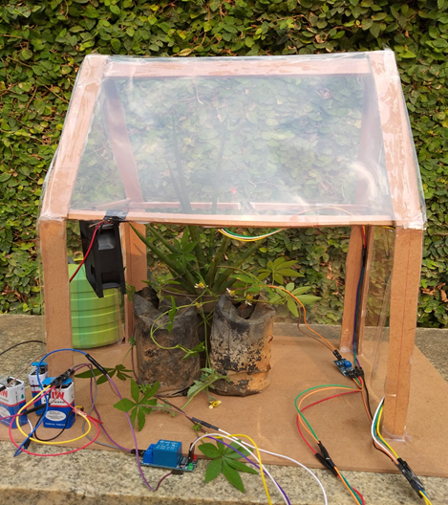

Fig 1.1 Smart Greenhouse Prototype

1. All the above mentioned aspects of present agricultural practices should be improved to get higher yield. Hence, we move towards a smart greenhouse model (fig 1.1). A Greenhouse can be defined as a close structure which is used to protect the plants from external factors such as climatic conditions, pollution, etc. In IOT - based smart greenhouse farming, a system is built for monitoring the crop field with the help of sensors (light, humidity, temperature, soil moisture, etc.) and automating the irrigation system, where the plant is provided with an environment for its optimum growth.
2. Water received from the combination of various sources like canal, rain water harvesting and from purchase from tube well owners is stored in an underground tank. Motor pump is kept inside the tank. Moisture level is measured by sensor and whenever moisture level decreases motor pump supplies water.
3. Due to the closed structure of greenhouse, insects and pests cannot enter inside, thereby eliminating the requirement of insecticides and pesticides. Growing LED lights are switched on whenever light intensity is low for photosynthesis, this ensures faster rate of growth.
4. The humidity and temperature of air in a greenhouse are measured by sensor and whenever temperature is high or air moisture becomes too low, fan is turned on to provide the required moisture and cool down the temperature.
   1. **Motivation**

There are several potential motivations for implementing a smart greenhouse system using Blynk and ESP32:

* Automation and Control: A smart greenhouse system allows for automated control of the environment, such as adjusting the temperature, humidity, and lighting to optimal levels for plant growth. This can save time and effort for the greenhouse owner and improve plant health and yield.
* Energy Efficiency: A smart greenhouse system can be designed to be energy-efficient, for example by automatically adjusting lighting and temperature settings based on the time of day and weather conditions. This can reduce energy consumption and costs.
* Remote monitoring and control: With Blynk and IoT, greenhouse owners can monitor and control their greenhouse systems remotely, allowing them to make adjustments and take action from anywhere.
* Reduced labour costs: A smart greenhouse system can automate many tasks, such as watering and temperature control, reducing the need for manual labour. This can save time and money for greenhouse operators.
* Data collection and analysis: Smart greenhouse systems can collect and analyse data on environmental conditions, plant growth, and resource usage, providing valuable insights for optimizing operations.
* Environmental benefits: By optimizing resource use and reducing waste, a smart greenhouse system can have a positive impact on the environment. In addition, by providing fresh produce locally, greenhouse operations can reduce the environmental impact of transportation and distribution.

Hence, a smart greenhouse system using Blynk and ESP32 can provide numerous benefits greenhouse owners, including improved plant health and yield, greater control and flexibility and energy savings.

**1.3 Objective and Scope**

The objective and scope of a greenhouse system can be summarized as follows**:**

* To provide an enclosed space where plants can be grown under controlled conditions.
* To extend the growing season by protecting plants from adverse weather conditions such as frost, excessive heat, and wind.
* To allow for the cultivation of plants that are not adapted to the local climate, such as tropical or subtropical plants in colder regions.
* To enable the production of crops year-round, thus increasing food security and reducing dependence on seasonal fluctuations in crop production.
* To facilitate research and experimentation in plant breeding, genetics, and other related fields.
* To reduce the environmental impact of agriculture by minimizing the use of pesticides and fertilizers, and by reducing water usage.
* To provide opportunities for sustainable and profitable small-scale agriculture, such as urban farming and community gardens.
* To contribute to the development of alternative and innovative farming practices that can help address global challenges such as climate change, food security, and resource scarcity.
* The system will consist of an ESP32 microcontroller that will control various sensors and actuators.
* The system will be connected to the internet using Wi-Fi, allowing users to remotely monitor and control the greenhouse.
* The system will use Blynk, a mobile application, to display sensor data and allow users to control the environment in real-time.
  + The sensors used in the system will include temperature and humidity sensors, light sensors, and soil moisture sensors. The actuators used in the system will include a water pump, fans, and a grow light.
  + The system will be designed to be modular, allowing farmers to add or remove sensors and actuators depending on their needs.
  1. **Organization of Report**
* Chapter 1: It provides an overview of Smart Greenhouse System using ESP32, motivation and objective and scope.
* Chapter 2: Explains about the research works conducted in the area of Smart Greenhouse System and methodology adopted to overcome the limitation.
* Chapter 3: Gives an insight about the methodology and implementation.
* Chapter 4: Describes the various circuits employed towards the implementation of the proposed work and also software and hardware requirements.
* Chapter 5: Result obtained upon working of the prototype.
* Chapter 6: Provides conclusion and summarises the entire work.

**CHAPTER – II**

**LITERATURE SURVEY**

**[1] P.Dedeepya, Srinija, M.Gowtham Krishna, G.Sindhusha , T.Gnanesh “Smart Greenhouse Farming based on IOT” IEEE 2nd International conference on Electronics, Communication and Aerospace Technology, 2018.**

The study describes how Internet of Things (IoT) devices including temperature sensors, humidity sensors, soil moisture sensors, and light sensors may be utilised to collect data on various factors in a greenhouse setting. Using algorithms and machine learning approaches, this data may subsequently be examined to improve crop growth and production. The suggested system also incorporates a mobile application for real-time monitoring and control of the greenhouse environment, allowing farmers to make educated crop management decisions. According to the report, using IoT technology in greenhouse farming may increase crop output, minimise resource waste, and make farming more efficient and sustainable.

**[2] Aji Hanggoro, Rizki Reynaldo, Mahesa Adhitya Putra “Green House Monitoring and Controlling Using Android Mobile Application “ IEEE Quality in Research, 2017.**

The article "Green House Monitoring and Controlling Using Android Mobile Application," given at the IEEE Quality in Research conference in 2017, discusses a system that remotely monitors and controls a greenhouse environment using an Android mobile application. To collect data on the greenhouse environment, the system employs several sensors like as temperature, humidity, and light sensors. The information is subsequently sent to the Android application through Wi-Fi or cellular network. The Android application monitors the greenhouse environment in real time and allows farmers to remotely alter elements such as temperature and humidity. The app also has an alarm mechanism that notifies farmers if any of the parameters exceed the specified range.

According to the report, using the Android application in greenhouse farming may increase crop output, cut labour and operating expenses, and make farming more efficient and sustainable.

**[3] Yung Sheng Chang, Yi Hsiung Chen, Sheng Kai Zhou “A smart lighting system for greenhouses based on Narrowband-IoT communication “ IEEE IMPACT on International MicroSystem, 2018.**

This paper discusses a smart lighting system for greenhouses that employs Narrowband-IoT (NB-IoT) communication technology. The system connects numerous sensors, including as temperature, humidity, and light sensors, to a central control unit through NB-IoT connectivity. The sensor data is analysed by the control unit, and the lighting system is controlled appropriately. The intelligent lighting system is intended to offer ideal lighting conditions for various phases of plant growth. It combines natural and artificial lighting to ensure that plants receive the necessary quantity of light for maximum development. The system also features a mobile application that enables farmers to remotely monitor and control the lighting system. The application provides real-time data on the greenhouse environment and allows farmers to adjust the lighting system to meet their specific needs. The paper concludes that the use of NB-IoT communication technology in greenhouse farming can improve crop yield, reduce energy consumption, and make farming more efficient and sustainable.

**[4] Ravi Kishore Kodali, Vishal Jain and Sumit Karagwal “IoT based Smart Greenhouse”. Publish through Research Gate, December 2016.**

The researchers start by outlining the difficulties associated with traditional greenhouse systems, such as excessive resource usage and uneven produce quality, and then offer a remedy using IoT technology. They then go over the components and design of their planned smart greenhouse system, which includes sensors to measure temperature, humidity, soil moisture, and light intensity, as well as an actuator to operate the watering system. the software components of the system, including the cloud platform for data storage and analysis, the mobile application for user interaction, and the machine learning algorithm for predicting the optimal conditions for plant growth. The authors provide a thorough explanation of the machine learning algorithm, which uses data collected from the sensors to make predictions about the ideal environmental conditions for plant growth. the results of their experimental implementation of the smart greenhouse system, which demonstrated improved resource efficiency and yield quality compared to traditional greenhouse systems. They also discuss the potential applications of their system in large-scale commercial farming and the importance of sustainability in modern agriculture.

**[5] Li Daoliang. “Internet of things and wisdom agriculture” . Agricultural Engineering, 2012.**

The challenges faced by modern agriculture, such as population growth, resource scarcity, and climate change, and argues that the IoT has the potential to address these challenges through improved data collection, analysis, and decision-making. The paper provides a comprehensive overview of the different components of IoT technology and their potential applications in agriculture, including sensors for data collection, communication networks for data transmission, and cloud computing for data analysis. the challenges associated with implementing IoT technology in agriculture, such as high costs, technical complexity, and data security concerns. The author suggests that these challenges can be addressed through collaboration between different stakeholders, such as farmers, researchers, and industry partners, and by developing standardized protocols and guidelines for IoT implementation. emphasizes the importance of collaboration and standardization for realizing the full potential of IoT technology in agriculture.

**CHAPTER-III**

**METHODOLOGY**

The aim of this project is to design a smart automated greenhouse system that provides a real-time information on critical climate factors including temperature, humidity, light exposure, etc. and soil moisture across the greenhouse.

Component Selection: The first step is to select the components required for the smart greenhouse system. This includes a soil moisture sensor to measure the moisture content of the soil, an LDR sensor to measure the light intensity, and a DHT11 sensor to measure the temperature and humidity. In addition, a fan, motor pump, and LED are required for controlling the environmental conditions inside the greenhouse, and an LCD display is needed to display the sensor readings and system status.

Hardware Setup: The next step is to set up the hardware components of the smart greenhouse system. This involves connecting the sensors, fan, motor pump, LED, and LCD display to the microcontroller. The soil moisture sensor and LDR sensor are connected to the analog input pins of the microcontroller, while the DHT11 sensor is connected to the digital input pin. The fan, motor pump, and LED are connected to the output pins of the microcontroller, and the LCD display is connected to the I2C interface of the microcontroller.

Software Development: The third step is to develop the software for the smart greenhouse system. This involves programming the microcontroller to read the sensor values and control the fan, motor pump, and LED based on the sensor readings. The program should also display the sensor readings and system status on the LCD display.

Testing: The final step is to test the smart greenhouse system to ensure that it is functioning correctly. This involves placing the soil moisture sensor, LDR sensor, and DHT11 sensor inside the greenhouse and measuring the sensor readings. The fan, motor pump, and LED should respond to the sensor readings and maintain the desired environmental conditions inside the greenhouse. The LCD display should also display the sensor readings and system status correctly.

This system can be used to maintain the optimal environmental conditions inside the greenhouse and improve the yield and quality of plants.

1. **Block Diagram**

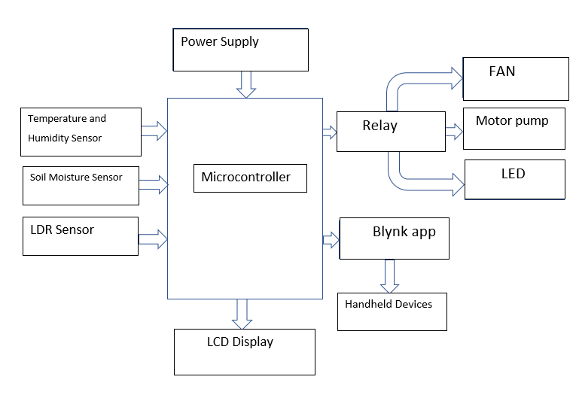

Fig 3.1 Block Diagram of proposed Greenhouse System

1. **Flowchart**

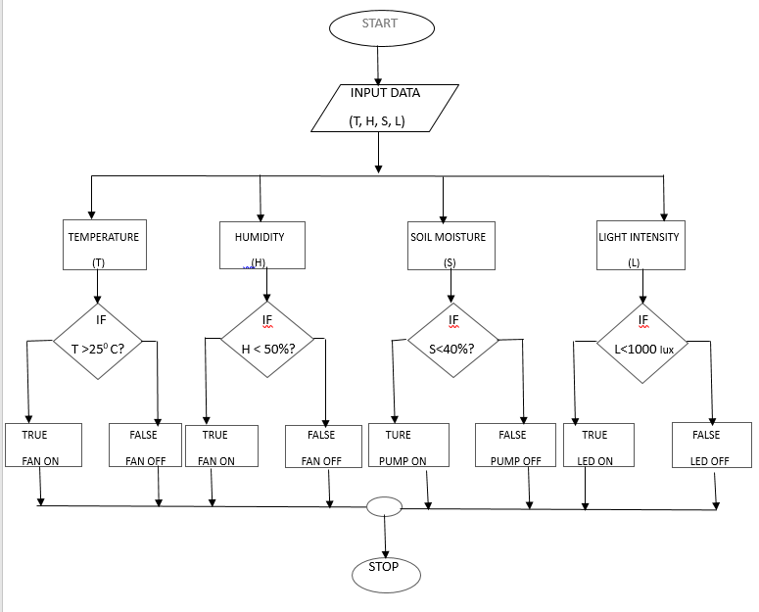

Fig 3.2 Flowchart of proposed Greenhouse System

1. **System Architecture**
   1. **Hardware Used**

Design of the hardware for greenhouse monitoring is used to control the environment condition of given house to get good condition. The monitoring of greenhouse component consists of sensor –

* Temperature Sensor (DHT11)
* Soil moisture sensor
* Light intensity (LDR)
* Microcontroller - ESP32
* LCD-16*2
* RELAY MODULE
* Battery-9V
* DC motor
* DC fan
* LED
* Jumper wires.
  1. **Software Used**
* ARDUINO IDE
* Blynk IOT application
  1. **Architecture**

This proposed system consists of sensing part, controlling part, monitoring part and a message sending and receiving part. In the monitoring part the sensors are included i.e. temperature and humidity sensor, soil moisture sensor and light detection sensor. These sensors will sense the various parameters of the environment. And the values are displayed on the LCD display. These sensors are connected to the microprocessor ESP-32 as shown in fig-3.1which is a controlling part. The actuators (Fan, Pump, LED) are switched ON based on the instructions passed to the microcontroller. An LCD is employed to show the condition inside the greenhouse. The system works in such a way that when the environmental parameters across a safety threshold, the sensors detect a change and the microcontroller reads the data from its input ports and performs the suitable action in order to bring the parameter back to its required level.

The microprocessors will continuously display climatic conditions on LCD and will send this data over an internet and the user using Blynk IOT application will get the climatic report.

From the Fig 3.1, the left hand side consists sensing part and right hand side consists actuators and to center the microprocessor.

1. **Working**

The working of smart greenhouse system is illustrated in the form of a flowchart as shown in Fig-3.2**.** The maximum temperature within the greenhouse is set as 25 degrees Celsius, the soil moisture content threshold is set between 40%, and the light intensity content threshold is set between 1000 lux. An artificial environment is thus created to improve the crop yield per square meter on continuous monitoring of climatic parameters resulting in an optimal environment. As shown in Fig-3.2**,** when the temperature exceeds the set optimum threshold value i.e. 25 degrees Celsius, the relay will perform the required action which is to bring the temperature down when it’s too high by turning ON the FAN and when the temperature reaches the set optimum value, the FAN turn OFF. Similarly, when the soil moisture value is less than the set optimum value, then the relay performs the required action and turn ON the motor pump and when it reaches the set threshold value, the motor pump turns OFF. Also, with the light intensity fixed at 1000 lux, if the value happens to get higher, the light is turned OFF which results in reduction of light intensity in order to avoid the production of bad crop. When the value happens to get lower, the light is turned ON.

**CHAPTER - IV**

**HARDWARE AND SOFTWARE REQUIREMENTS**

1. **Hardware Requirements**
   1. ESP-32: The ESP32 (Fig 4.1) is a powerful microcontroller with Wi-Fi and Bluetooth capabilities that has become increasingly popular in the IOT space. Its low cost, low power consumption, and small form factor make it ideal for use in IOT devices. The ESP32 can be used in a variety of IOT applications such as, home automation, industrial automation, smart farming and many more. Its Wi-Fi and Bluetooth capabilities allow it to connect to the internet and communicate with other devices, such as sensors and actuators, over a wireless network. This enables the creation of IOT devices that can be remotely monitored and controlled, improved efficiency, and reducing costs.

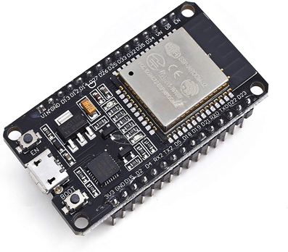

Fig 4.1 ESP-32

* 1. DHT11: The DHT11(Fig 4.2) sensor is a low-cost digital temperature and humidity sensor that can be used to measure the temperature and humidity of the surrounding environment. The DHT11 sensor communicates with a microcontroller using a one-wire interface and provides the data in a 40-bit format. The output of this sensor is digital and it has fast response time, good accuracy and high resolution.

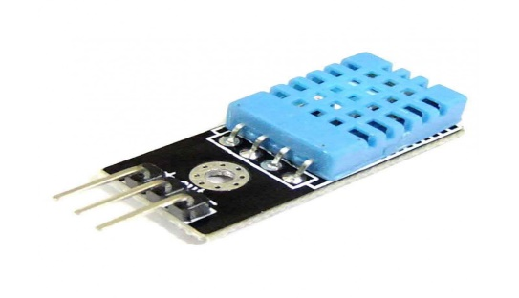

Fig 4.2 DHT11 Sensor

* 1. Soil moisture Sensor: A soil moisture sensor (Fig 4.3) is a device that measures the water content in the soil. It is used to determine when plants need watering, to prevent over watering, and to conserve water by watering only when necessary. Soil moisture sensors can be used in variety of applications other than greenhouse such as agriculture, landscaping and environmental monitoring. Therefore, soil moisture sensors are a valuable tool for managing water resources, promoting efficient irrigation practices and ensuring healthy plant growth in various settings.

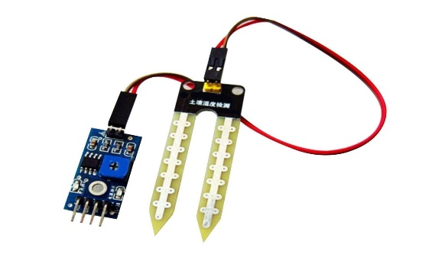

Fig 4.3 Soil Moisture Sensor

* 1. LDR Sensor: A LDR sensor (Fig 4.4) is commonly used in IOT applications for detecting light levels. An LDR is a passive electronic component that can detect changes in the intensity of light falling on its surface. In an IOT system, an LDR sensor is connected to a microcontroller such as an Arduino or Raspberry Pi, which can then process the data and send it to the cloud platform for further analysis or action. Some of the common use cases of LDR sensors in IOT are: Smart lighting, Security System, Agriculture, Weather Monitoring. Hence, LDR is considered as versatile and inexpensive sensor that can be used in a wide range in IOT application to detect light levels and trigger actions based on data collected.

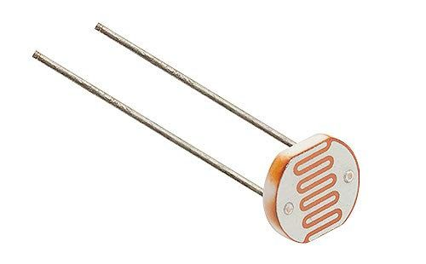

Fig 4.4 LDR Sensor

* 1. 5V Fan: The use of a 5V FAN (Fig 4.5) in smart greenhouse is essential for maintaining a suitable growing environment for plants. A fan helps to circulate air throughout the greenhouse, which is crucial for controlling temperature, humidity, and air quality. In smart greenhouse, the fan can be controlled by a system that monitors the environment and makes the adjustments to keep it within the ideal range for plant growth. Therefore, fans help to prevent the build-up of stagnant air moisture, which can lead to the growth of mold and disease in plants.

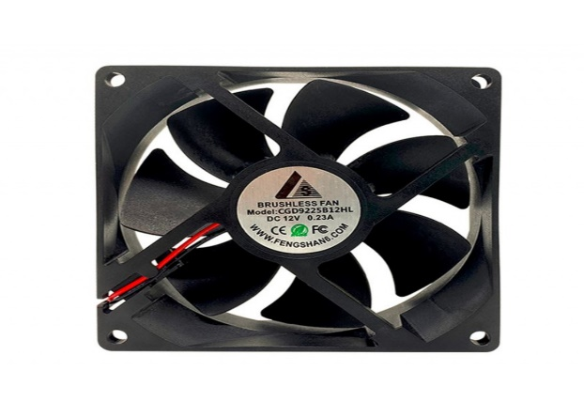

Fig 4.5 Fan

* 1. Motor Pump: A motor pump (Fig 4.6) is an essential component in smart greenhouse as it helps to automate the watering system. The motor pump can be controlled by a microcontroller or a computer, which can be programmed to turn the pump ON and OFF at specific times or under certain conditions. It helps to optimize the watering system, ensuring the plants receive the right amount of water at right time. Hence, this helps to improve plant growth and yield while also conserving water and reducing waste.

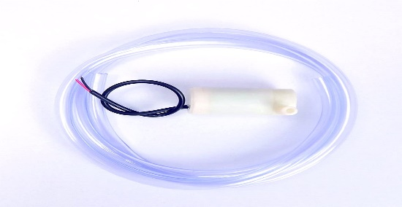

Fig 4.6 Motor Pump

* 1. LED: LED lights (Fig 4.7) are often used in smart greenhouse for their efficiency, long lifespan and ability to provide specific wavelengths of light to plants, promoting optimal growth and development. In smart greenhouse, LED lights can be programmed to turn ON and OFF at specific times and provide different light spectrums depending on the plant’s growth stage. Therefore, using LED lights can also help to reduce energy costs, as they require less compared to others. Additionally, LED lights produce less heat, reducing the need for additional cooling systems; which can also save energy.

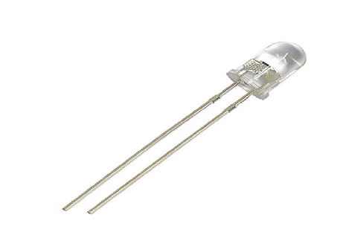

Fig 4.7 LED

* 1. LCD: LCD display (Fig 4.8) is commonly used in IOT devices to display information to users. The information displayed on an LCD can range from status messages to more complex data such as sensor readings or analytics. In addition, LCD’s can also be used to display alerts and notifications, such as warnings or system errors. This allows users to quickly identify and troubleshoot issues with their IOT devices. Hence, the use of LCD’s in IOT devices provides a simple and efficient way to communicate important information to users, improving the usability and functionality of the device.

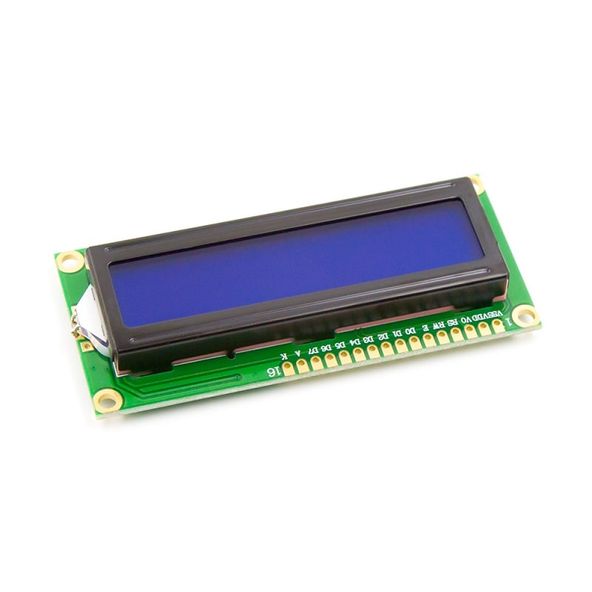

Fig 4.8 LCD Display

* 1. Relay Module: Relays (Fig 4.9) are commonly used in IOT applications to control high-power loads like motors, lights and heat systems. A relay is an electronic switch that can be controlled by low-power signal, such as one from an IOT device, to turn ON or OFF a high-power load. Relays work by using a small amount of electrical power to energize an electromagnetic coil, which creates a magnetic field that pulls or pushes a set of contacts to make or break a circuit. They are an essential component in many industrial automation systems, as well as in home and agricultural automation systems.

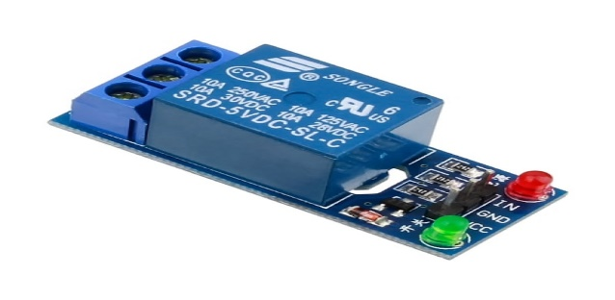

Fig 4.9 Relay Module

* 1. Jumper Wires: Jumper wires (Fig 4.10) are widely used in IOT projects to connect various components like sensors, actuators, microcontrollers and other electronic devices. These wires are insulated wires with connected on each end that can be plugged into breadboard or directly into microcontroller. Jumper wires allow for easy and quick connections between different electronic components. They are especially useful when prototyping IOT projects because they allow for easy experiments and modifications of the circuit without the need for soldering or other permanent connections.

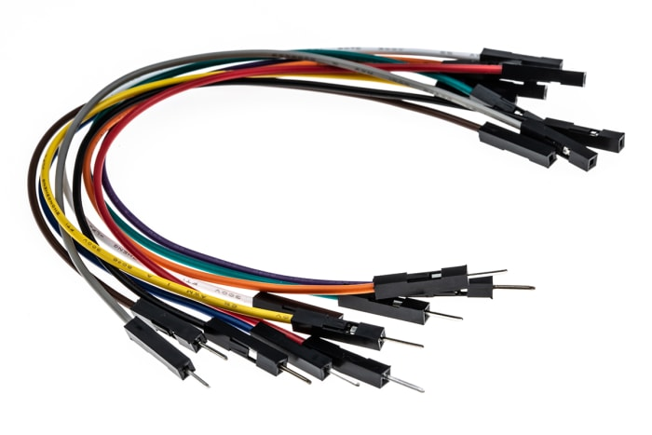

Fig 4.10 Jumper wires

* 1. Battery: Batteries (Fig 4.11) are used in IOT devices because they provide a portable and reliable source of power. Since many IOT devices are deployed in remote or hard-to-reach locations, it is often difficult or impossible to provide a constant power source. IOT devices often need lightweight, which means they cannot accommodate large or heavy batteries. Hence, batteries play a critical role in powering IOT devices and enabling them to communicate and perform their intended functions.

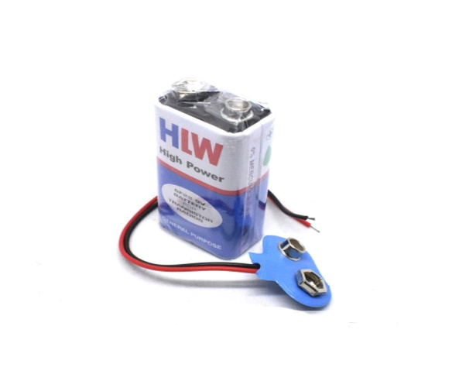

Fig 4.11 Battery

1. **Software Requirements**
2. Arduino IDE kit: Arduino IDE (Integrated development environment)

(Fig 4.12) is a kit using microcontroller to make the sense and control more flexible. This kit is an open source platform with simple board and development environment to write software. The Arduino IDE consists of microcontroller board i.e. ESP32. This microcontroller has 48 pins with multiple inputs and outputs beside this microcontroller. It also supports various programming languages, including C, C++ and features a simple syntax that is easy to learn. It is also compatible with multiple operating systems, including Windows, Mac, Linux. Therefore, the Arduino IDE provides an accessible and versatile platform for programming Arduino boards, making it a popular choice for both hobbyists and professional developers.



Fig 4.12 Arduino IDE Logo

1. Blynk Application: Blynk (Fig 4.13) is a platform for building IOT (internet of things) projects that allows you to control hardware remotely using a mobile app. Blynk provides an app that you can download onto your smartphone or tablet, and cloud-based server that you can connect your hardware to the app. The Blynk server is the central component of the Blynk platform. It acts as a bridge between your hardware and the Blynk app, and allows you to send and receive data in real time. The server is responsible for managing the authentication and authorization of devices, as well as handling the communication between devices and the app. And hence, the Blynk server is an important component of the Blynk platform that enables developers and hobbyists to build IOT projects and control their hardware remotely using mobile app.



Fig 4.13 Blynk Application Logo

**CHAPTER - V**

**RESULTS AND DISCUSSION**

1. **Results**

* All sensors should sense the data and fetch the environmental conditions and send the data to arduino. Sensors which include DHT11, SOIL MOISTURE, LDR.
* The sensed data by the sensors is displayed on LCD display (Fig 5.3), Serial monitor (Fig 5.1) and Blynk (Fig 5.2).
* If there are variations in the sensed data/values, it performs an appropriate action in order for crop yield.

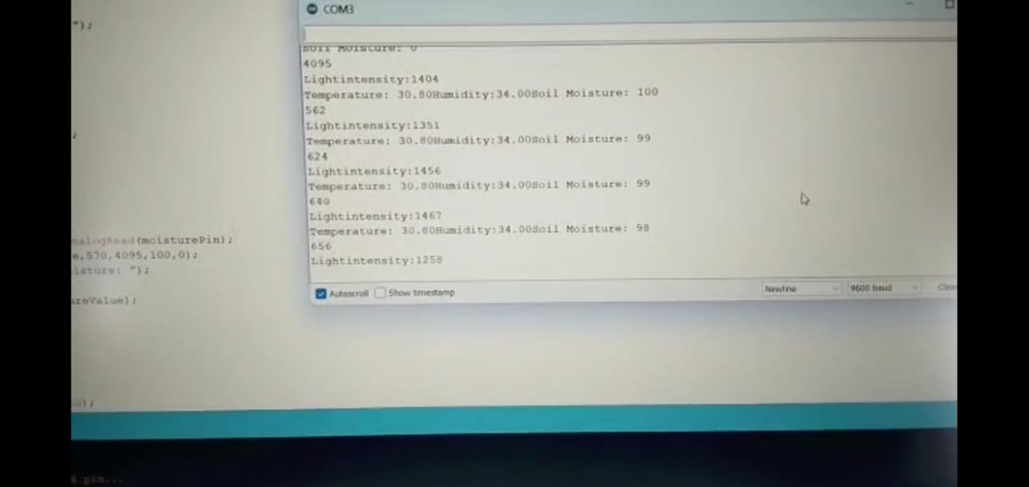

Fig 5.1 Arduino IDE Console Log showing sensor values

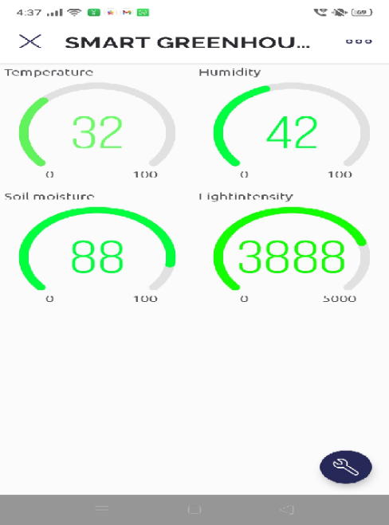

Fig 5.2 Blynk Application showing sensor values

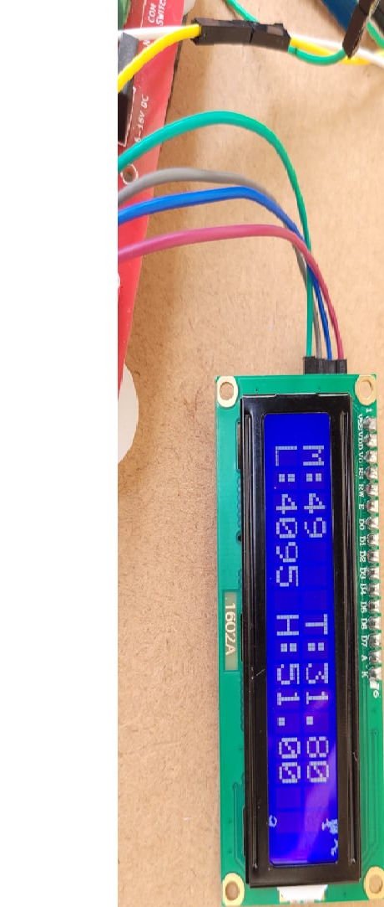

Fig 5.3 LCD showing sensor values

* 1. **Observation and Findings**
     1. If Temperature is greater than 25 degree celcius, FAN gets ON (Fig 5.4) and vice versa.

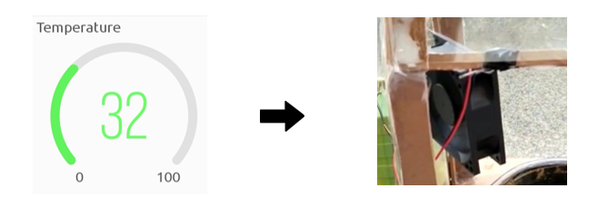

Fig 5.4 Fan Turning On

* + 1. If Soil moisture content is more than 40%, motor pump turns OFF (Fig 5.5) and vice versa.

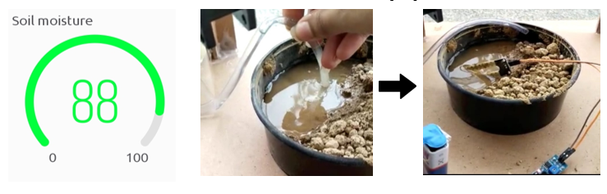

Fig 5.5 Pump Turning Off

* + 1. If Light intensity if less than 1000lux, LED turns OFF (Fig 5.6) and vice versa.

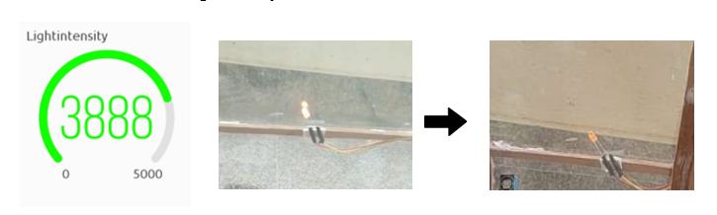

Fig 5.6 Led Turning Off

* + 1. The data sensed by the sensors is getting updated on the Blynk application. This provides real time analysis, reduces the amount of resources, improves efficiency and ensure optimal growing conditions for plants.
       - BLYNK (Fig 5.7) is used display the sensor display.
       - The threshold values of our smart greenhouse system are:
         1. Temperature – 25 degree indicates green colour, 26-35 degree indicates yellow , above 35 degree indicates red colour
         2. Humidity -50% - GREEN Colour , 50-55% - YELLOW Colour and 55% - RED Colour
         3. Soil moisture – 40% - GREEN Colour , 40-35% - YELLOW Colour and 40% - RED Colour
         4. Light intensity – 1000 lux - GREEN Colour , 999-800 - YELLOW Colour and 800 - RED Colour
       - Description of Colors used in Blynk:
         1. **Green:** controlling all the parameters and greenhouse is in safe condition.
         2. **Yellow:** A little are variations in controlling the parameters and greenhouse is edge of safe condition.
         3. **Red:** A large are variations in controlling the parameters and greenhouse is in unsafe condition.

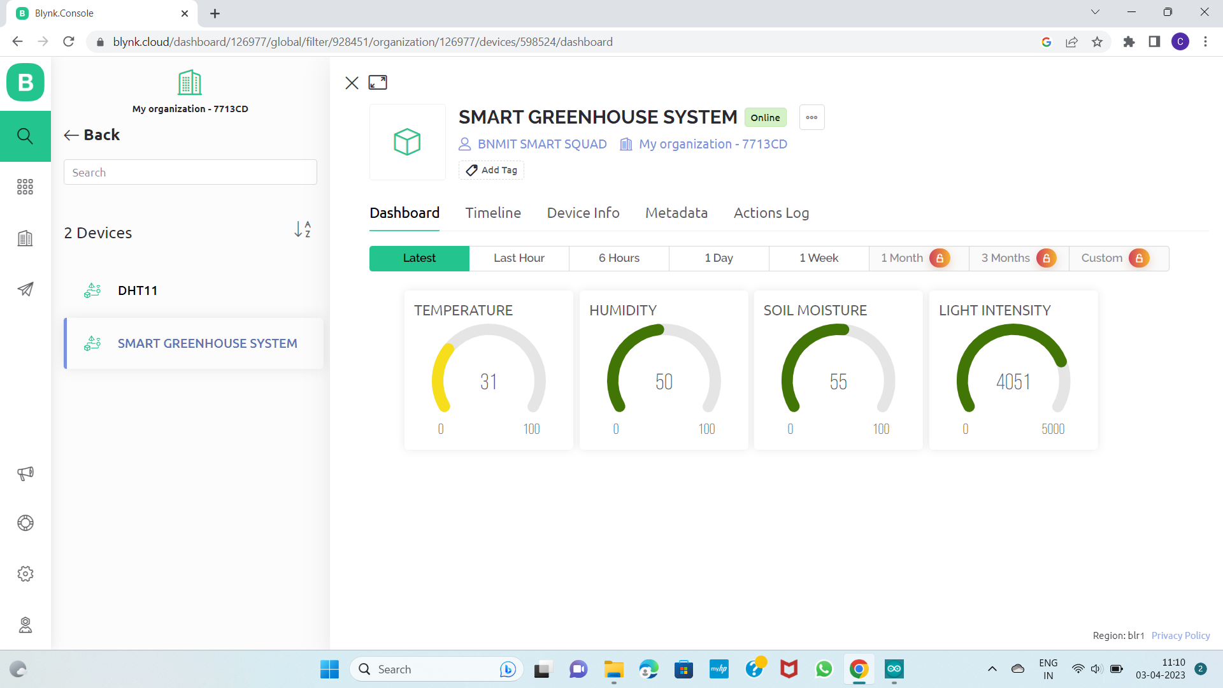

Fig 5.7 Blynk Readings with colors for illustration

1. **Discussion**

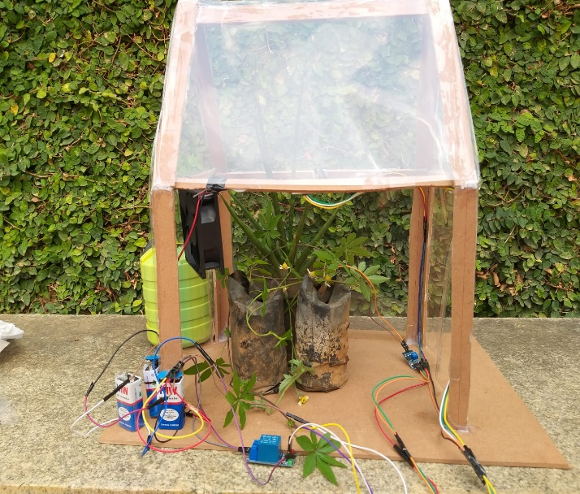

Fig 5.8 Smart Greenhouse System Frontal view

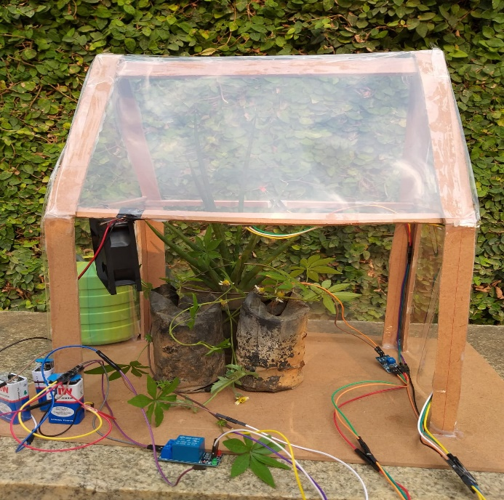

Fig 5.9 Smart Greenhouse System Side view

A smart greenhouse system (Fig 5.8 and 5.9) would be a system that automatically controls the temperature and humidity conditions in a greenhouse using IoT devices and sensors. The system would be able to monitor the environmental conditions in the greenhouse, such as temperature, light intensity, and soil moisture levels, and adjust the conditions to ensure optimal plant growth.

The IoT devices used in the system could include temperature and humidity sensors, water pump, and fans. These devices would be connected to Arduino esp32 board, which would collect and process data from the sensors and control the devices.

The benefits of such a system are numerous. Firstly, it would improve the efficiency of greenhouse farming by reducing the need for manual monitoring and control. Secondly, it would ensure optimal growing conditions for plants, leading to higher crop yields and better quality produce.

Lastly, it would reduce the environmental impact of greenhouse farming by minimizing energy and water usage.

However, there are some challenges to implementing a smart greenhouse system project. Firstly, the cost of setting up the system could be prohibitive for small-scale farmers, and the technology may not be accessible or affordable in certain regions. Additionally, there would be concerns around the security of data and the reliability of the IoT devices.

A smart greenhouse system has the potential to revolutionize greenhouse farming and improve efficiency and sustainability in agriculture.

**CHAPTER - VI**

**CONCLUSION AND FUTURE SCOPE**

* 1. **Conclusion**

There are ways to make a smart move towards the need of agriculture field Technology of today's era is providing hand in improvement .Agricultural professional and the management have to look in this matter .In conventional farming ,we have to face lots of problems .With help of technology we can able to produce insecticide and pesticide free crops and create a suitable environment for the proper growth of plants .Most important the smart customer of today's era are directly connected to the farmer . So, farmer knows the requirement of end users that improve the quality of crops the greenhouse project with Arduino provides an innovative and efficient solution for controlling the environment inside a greenhouse. By using sensors to monitor the temperature, humidity, and soil moisture, the system allows for precise control of the growing conditions. The Arduino microcontroller provides a user-friendly interface for adjusting the settings and receiving real-time data on the greenhouse's conditions. The integration of a water pump and fan provides automatic irrigation and ventilation, making the system low-maintenance and reducing the need for human intervention. The greenhouse project with Arduino is an excellent example of how technology can improve agricultural practices and assist in sustainable food production. We can also expect to see even more advanced and intuitive gesture recognition systems that make our lives easier and more comfortable.

* 1. **Future Scope**

The future scope of smart greenhouse system project is promising and vast. With the increasing demand for fresh and healthy produce, the use of advanced technologies like IoT is gaining popularity among farmers and greenhouse growers.

Some of the potential future developments in this field are:

* Advanced Sensing and Monitoring: The use of advanced sensors and monitoring devices enable farmers to track various parameters such as temperature, humidity, soil moisture, plant health, and more. The future scope of this technology is to develop more advanced and affordable sensors that can gather more data at a faster rate.
* Precision Farming: The application of IoT in smart greenhouse systems can lead to precision farming, where farmers can control various parameters, such as water and fertilizer, based on the needs of the plants. This will improve the yield and quality of produce and reduce wastage.
* Automation: The future scope of smart greenhouse system is to automate various tasks such as watering, heating, cooling, and lighting. This will reduce the workload of farmers and save time and money.
* AI-based Systems: The use of artificial intelligence can benefit greenhouse systems by predicting plant growth, pests, and diseases. This will help farmers to take preventive measures and increase the efficiency of the greenhouse system.
* Eco-Friendly Farming: smart greenhouse systems can reduce the use of pesticides and chemicals, leading to eco-friendlier farming practices. In the future, these systems can be developed with more sustainable materials and renewable energy sources.

The use of IoT in greenhouse systems has a lot of potential for future development and growth. It can revolutionize the agriculture industry and provide more sustainable, healthy, and efficient farming practices.

**REFERENCES**

[1] P.Dedeepya, Srinija, M.Gowtham Krishna, G.Sindhusha , T.Gnanesh “Smart Greenhouse Farming based on IOT” IEEE 2nd International conference on Electronics, Communication and Aerospace Technology, 2018.

[2] Aji Hanggoro, Rizki Reynaldo, Mahesa Adhitya Putra “Green House Monitoring and Controlling Using Android Mobile Application “ IEEE Quality in Research, 2017.

[3] Yung Sheng Chang, Yi Hsiung Chen, Sheng Kai Zhou “A smart lighting system for greenhouses based on Narrowband-IoT communication “ IEEE IMPACT on International MicroSystem, 2018.

[4] Ravi Kishore Kodali, Vishal Jain and Sumit Karagwal “IoT based Smart Greenhouse”. Publish through Research Gate, December 2016.

[5] Li Daoliang. “Internet of things and wisdom agriculture” . Agricultural Engineering, 2012.

[6] Bao Jie Ji Wan Zhong Lei ,Shao Long Ji , Cai Hong Zou ,“Design and analysis of intelligent greenhouse environment control system based Engineering” (CCIE), 2011.

[7] Zhong Ke, Chen Xiangdong, “Design on Smart Home Service Gateway based on IOT, Communications Technology”, Vol. 45, Issue 8, 2012.

[8] Mo Lianguang, “Study on Supply-Chain of Agricultural Products Based on IOT”, 2014 Sixth International Conference on Measuring Technology and Mechatronics Automation.

[9] P. S. Asolkar, Prof. Dr. U. S. Bhadade, “An Effective Method of Controlling the Greenhouse and Crop Monitoring Using GSM” , 2015 International Conference on Computing Communication Control and Automation.

[10] <https://youtu.be/ju51LORqblw>

[11] <https://youtu.be/RUdTPZAVwy8>

[12] “Green House Automation Using IOT” by JET. “IOT Greenhouse”: <https://youtube/owlkoisfyy>.

[13] Interaction Journal of creative research thoughts (IJCRT) “IOT Based Smart Greenhouse Automation”. By: Pranjali .D.Shiyali, Hemangi Thombre, Gautam Tyagi, Aarti Chauhan.

[14] Prince Immanuel Alexander.S, Dineshkumar.J, Lavanya.G. “IOT Based Greenhouse Monitering Controlling’. 2018 IJRTI.

[15] IRJET June 2020, [www.irjet.net](http://www.irjet.net/) “IOT Based advanced greenhouse system”. By: Pooja p Korade, Amrutha A Pandav, Varsha R Kamble.

**Appendix**

#define BLYNK_TEMPLATE_ID "TMPLpTHOpP8x" //Template ID

#define BLYNK_TEMPLATE_NAME "SMART GREENHOUSE SYSTEM" //Device name

#define BLYNK_AUTH_TOKEN "Q3O2nUrSDJi-I1KhdkjPS7F0b-a3gscx" //Auth token

#define BLYNK_PRINT Serial

#define BLYNK_PRINT Serial

#define DHTPIN 32

#define DHTTYPE DHT11

#define PUMP 13

#define LDR 36

#define FAN 14

#include "DHT.h"

#include <Adafruit_Sensor.h>

#include <DHT.h>

#include <DHT_U.h>

#include <WiFi.h>

#include <BlynkSimpleEsp32.h>

#include<Wire.h>

#include<LiquidCrystal_I2C.h>

LiquidCrystal_I2C lcd(0x27,16,2);

const int moisturePin = 34;

int moistureValue; // initialize sensor value variable

int p;

const int ldrPin = 36;

const int led = 18;

int ldr = 100;

// Your WiFi credentials.

// Set password to "" for open networks.

char auth[] = BLYNK_AUTH_TOKEN; //WIFI ID(case sensitive)

char ssid[] = "vivo T1"; //WIFI PASSWORD(case sensitive)

char pass[] = "deepikA2004";

BlynkTimer timer;

// This function is called every time the device is connected to the Blynk.Cloud

DHT_Unified dht(DHTPIN, DHTTYPE);

BLYNK_CONNECTED()

{

// Change Web Link Button message to "Congratulations!"

Blynk.setProperty(V3, "offImageUrl", "https://static-image.nyc3.cdn.digitaloceanspaces.com/general/fte/congratulations.png");

Blynk.setProperty(V3, "onImageUrl", "https://static-image.nyc3.cdn.digitaloceanspaces.com/general/fte/congratulations_pressed.png");

Blynk.setProperty(V3, "url", "https://docs.blynk.io/en/getting-started/what-do-i-need-to-blynk/how-quickstart-device-was-made");

}

void myTimerEvent()

{

sensors_event_t event;

dht.temperature().getEvent(&event);

Serial.print("Temperature: ");

float temp = float(event.temperature);

Serial.print(event.temperature);

Blynk.virtualWrite(V1, temp);

Serial.println("°C");

lcd.setCursor(7,0);

lcd.print("T:");

lcd.print(temp);

dht.humidity().getEvent(&event);

Serial.print("Relative Humidity: ");

float hum = float(event.relative_humidity);

Serial.print(hum);

Blynk.virtualWrite(V2, hum);

Serial.println("%");

Serial.println("\n-------------------------------");

lcd.setCursor(7,1);

lcd.print("H:");

lcd.print(hum);

}

void setup()

{

pinMode(2,INPUT); //onboard led

Serial.begin(115200);

pinMode(14,OUTPUT); //fan

pinMode(13,OUTPUT); //pump

pinMode(36,INPUT); //ldr

pinMode(18,OUTPUT); //led

lcd.backlight();

lcd.init();

dht.begin();

Blynk.begin(auth, ssid, pass);

timer.setInterval(1000L, myTimerEvent);

}

void loop()

{

float temp;

if(temp > 25) //if temperature is greater then 25 the FAN will turn ON

{

digitalWrite(14,HIGH);

Serial.println("FAN is ON");

delay(1000);

}

else //if the temperature is less then 25 the FAN will turn OFF

{

digitalWrite(14,LOW);

Serial.println("FAN is OFF");

delay(1000);

}

int moistureValue = analogRead(moisturePin);

int p=map(moistureValue,570,4095,100,0);

Serial.print("Soil Moisture: ");

Serial.println(p);

Serial.println("%");

lcd.setCursor(0,0);

lcd.print("M:");

lcd.print(p);

delay(1000);

if(p<40&&p>1)

{ //if the soil moisrture is less then 40 the MOTOR will turn ON

digitalWrite(13,HIGH);

Serial.println("MOTOR is ON");

delay(1000);

}

else if(p>40) //if the soil moisrture is greater then 40 the MOTOR will turn OFF

{

digitalWrite(13,LOW);

Serial.println("MOTAR is OFF");

delay(1000);

}

int ldrValue = analogRead(36);

Serial.print("Lightintensity:");

Serial.println(ldrValue);

Serial.print(".");

Serial.println(" ");

lcd.setCursor(0,1);

lcd.print("L:");

lcd.print(ldrValue);

if(ldrValue < 1000) //if the lightintensity is less then 1000 the LED will turn ON

{

digitalWrite(18,HIGH);

Serial.println("LED is ON");

delay(1000);

}

if(ldrValue > 1000) //if the lightintensity is greater then 1000 the LED will turn OFF

{

digitalWrite(18,LOW);

Serial.println("LED is OFF");

delay(1000);

}

Blynk.virtualWrite(V0,p);

Blynk.virtualWrite(V3,ldrValue);

delay(1000);

Blynk.run();

timer.run();

}